1. Create a directory "exercise" inside your home directory and create nested(dir1/dir2/dir3) directory structure inside "excerise" with single command.

Commands are:

mkdir exercise

cd exercise

mkdir -p dir1/dir2/dir3

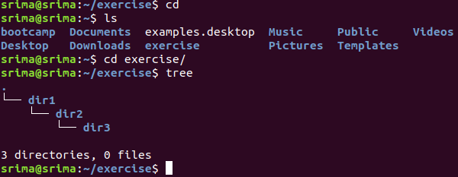

2.Create two empty files inside dir2 directory: emptyFile1,emptyFile2 in single command

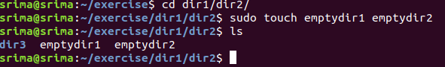

3.Create one file file1.txt containing text "hello world" and save it.

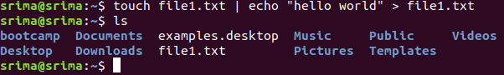

4.Find a "passwd" file using find command inside /etc. copy this files as passwd_copy and then rename this file as passwd_backup.

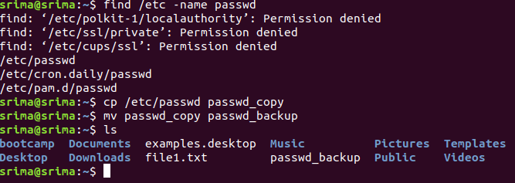

5.Try reading passwd_backup file in multiple tools: less,more,cat,strings etc and find the difference in their usage.

|  |  |  |  |
| --- | --- | --- | --- |
| Less | More | Cat | Strings |
| Can scroll up and down in the file | Can only scroll down. |  |  |
| Page by page | Page by page | Outputs the whole file at a single time | strings is a program in [Unix-like](https://en.wikipedia.org/wiki/Unix-like) [operating systems](https://en.wikipedia.org/wiki/Operating_system) that finds and prints text [strings](https://en.wikipedia.org/wiki/String_(computer_science)) embedded in [binary files](https://en.wikipedia.org/wiki/Binary_files) such as executables. |
| Less is faster | More is slower |  |  |

Less

less passwd_backup

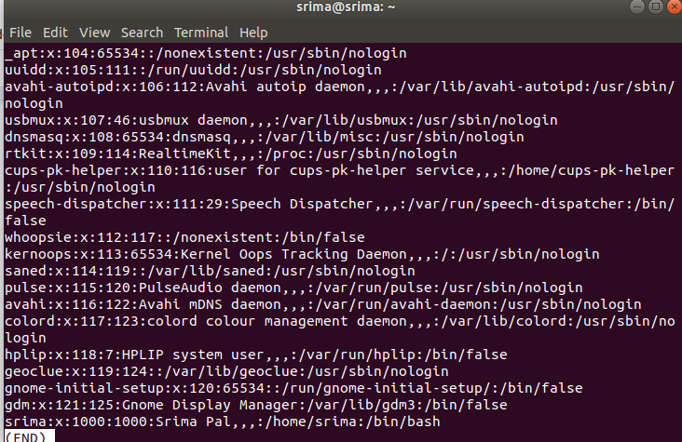

More

more passwd_backup

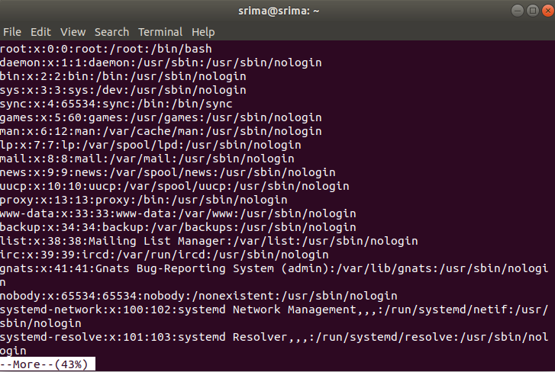

Cat

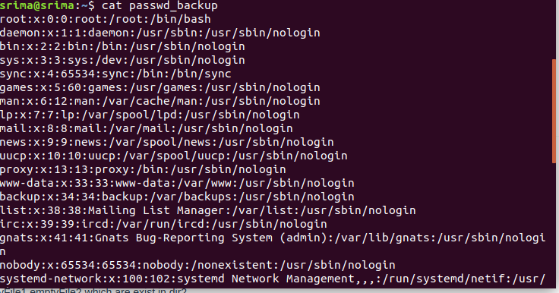

6. Find out the number of line in password_backup containing "/bin/false".



7. Get the first 5 lines of a file “password_backup” and Redirect the output of the above commands into file "output".

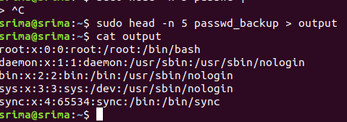

8. Create a "test" user,create its password and find out its uid and gid.

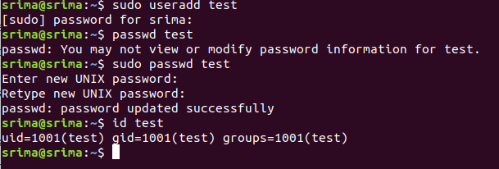

9. Change the timestamp of emptyFile1,emptyFile2 which are exist in dir2

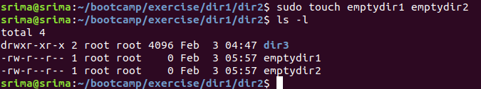

10.   
Login as test user and edit the "output" file created above. Since the permission wont allow you to save the changes. Configure such that test user can edit it.

1. Add group owner of the "output" file as the secondary group of testuser and check/change the "output" file permission if it is editable by group. Once done revert the changes
2. Make the file editable to the world so that test user can access it. Revert the changes after verification
3. Change the ownership to edit the file.

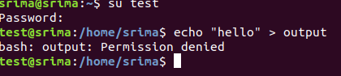

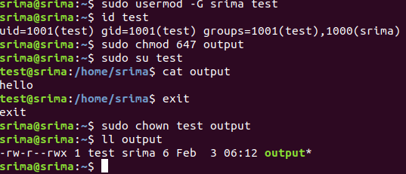

11. Create alias with your name so that it creates a file as "/tmp/aliastesting".





12. Edit ~/.bashrc file such that when you change to "test" user it should clear the screen and print "Welcome".

Contents of the ~/.bashrc file

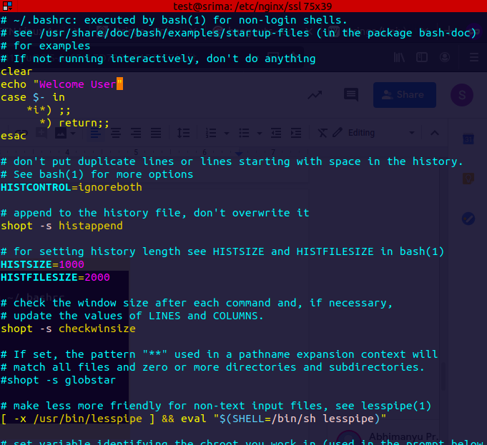

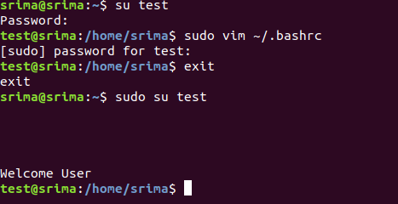

13. Install “zip” package.

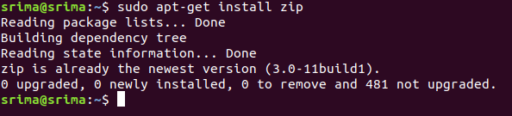

14. Compress "output" and "password_backup" files into a tar ball. List the files present inside the tar created.

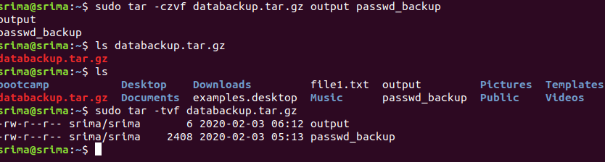

15. scp this file to test user

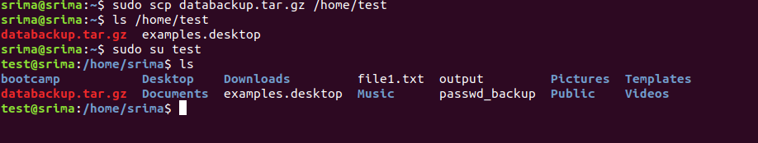

16. Unzip this tar bar by logging into the remote server

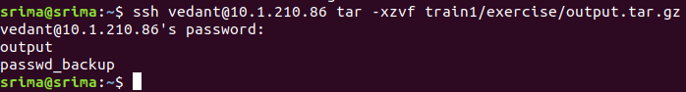

17. Download any image from web and move to desktop

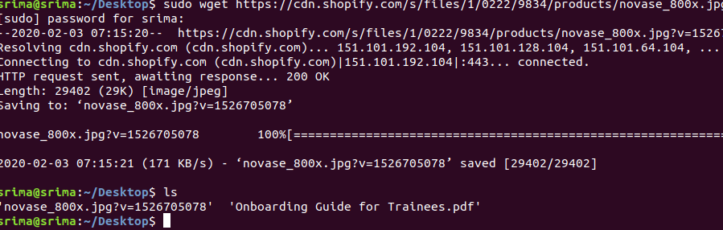

18. How to get help of commands usages.

Using --help

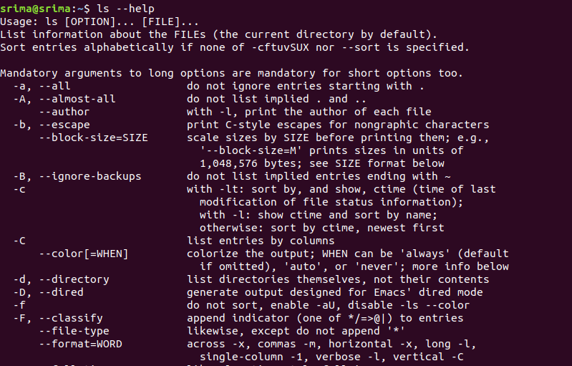

Using man

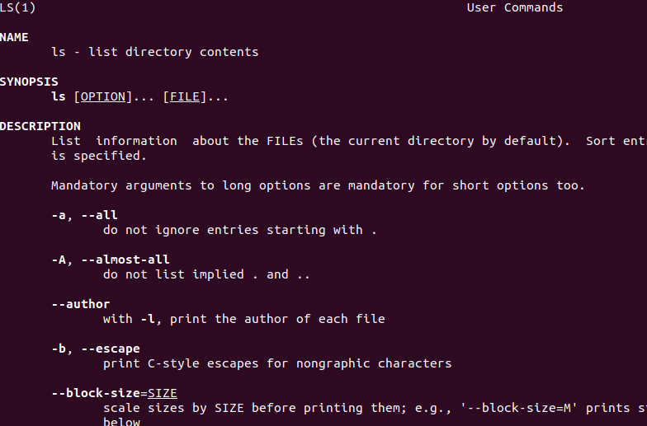

19. Create a symlink of /etc/services into /tmp/ports-info

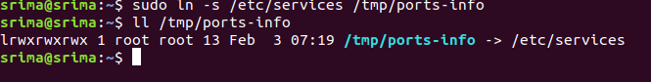

20. You are appointed as a Software/DevOps Engineer in ABC media services. On your first day you need to troubleshoot a problem. There is a command “xyz” somewhere installed in that linux system. But as a new joinee you do not have any idea about where is that Installed. How can you check that?

